**Comandos y salidas de R para ejercicio de clase 21 (ANOVA1)**

**a)**

**>tiempo<-scan()** #copiamos en la consola los 120 tiempos

> tiempo

[1] 51 64 70 63 78 55 67 75 82 61 53 60 62 83 77 90 85 60 70 58 40 61 66 37 54 77 75 57 85 82 30 51 68 45 56 49 42 50 72 45 53 47 57 83 54 50 64 65 46 68 33 52 52

[54] 42 42 66 58 44 71 39 39 54 69 47 66 44 56 55 67 47 58 39 42 45 72 72 69 75 57 54 34 62 50 58 48 63 74 45 71 59 92 73 86 83 49 68 66 83 80 67 74 63 77 77 54 79

[107] 80 85 78 64 80 80 57 75 76 78 83 74 78 84

**> pais<-as.factor(c(rep(1,30),rep(2,30),rep(3,30),rep(4,30)))**

> pais

[1] 1 1 1 1 1 1 1 1 1 1 1 1 1 1 1 1 1 1 1 1 1 1 1 1 1 1 1 1 1 1 2 2 2 2 2 2 2 2 2 2 2 2 2 2 2 2 2 2 2 2 2 2 2 2 2 2 2 2 2 2 3 3 3 3 3 3 3 3 3 3 3 3 3 3 3 3 3 3 3 3

[81] 3 3 3 3 3 3 3 3 3 3 4 4 4 4 4 4 4 4 4 4 4 4 4 4 4 4 4 4 4 4 4 4 4 4 4 4 4 4 4 4

Levels: 1 2 3 4

**> boxplot(tiempo~pais,names=c("A","B","C","D"),main="boxplot de los tiempos de fraguado")**

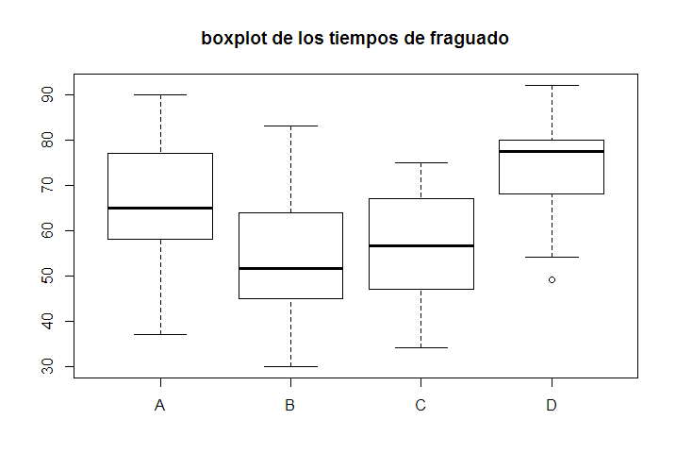

**b)**

**> salida<- aov(tiempo~pais)**

**> summary(salida)**

Df Sum Sq Mean Sq F value Pr(>F)

País 3 8773 2924.5 20.79 7.54e-11 ***

Residuals 116 16317 140.7

---

Signif. codes: 0 ‘***’ 0.001 ‘**’ 0.01 ‘*’ 0.05 ‘.’ 0.1 ‘ ’ 1

**c)**

**> salida$res**

1 2 3 4 5 6

-15.6000000 -2.6000000 3.4000000 -3.6000000 11.4000000 -11.6000000

7 8 9 10 11 12

0.4000000 8.4000000 15.4000000 -5.6000000 -13.6000000 -6.6000000

…. (son 120 en total)

**> salida$fit**

1 2 3 4 5 6 7 8

66.60000 66.60000 66.60000 66.60000 66.60000 66.60000 66.60000 66.60000

9 10 11 12 13 14 15 16

66.60000 66.60000 66.60000 66.60000 66.60000 66.60000 66.60000 66.60000

17 18 19 20 21 22 23 24

66.60000 66.60000 66.60000 66.60000 66.60000 66.60000 66.60000 66.60000

25 26 27 28 29 30 31 32

66.60000 66.60000 66.60000 66.60000 66.60000 66.60000 53.13333 53.13333

33 34 35 36 37 38 39 40

53.13333 53.13333 53.13333 53.13333 53.13333 53.13333 53.13333 53.13333

41 42 43 44 45 46 47 48

53.13333 53.13333 53.13333 53.13333 53.13333 53.13333 53.13333 53.13333

49 50 51 52 53 54 55 56

53.13333 53.13333 53.13333 53.13333 53.13333 53.13333 53.13333 53.13333

57 58 59 60 61 62 63 64

53.13333 53.13333 53.13333 53.13333 56.36667 56.36667 56.36667 56.36667

65 66 67 68 69 70 71 72

56.36667 56.36667 56.36667 56.36667 56.36667 56.36667 56.36667 56.36667

73 74 75 76 77 78 79 80

56.36667 56.36667 56.36667 56.36667 56.36667 56.36667 56.36667 56.36667

81 82 83 84 85 86 87 88

56.36667 56.36667 56.36667 56.36667 56.36667 56.36667 56.36667 56.36667

89 90 91 92 93 94 95 96

56.36667 56.36667 74.76667 74.76667 74.76667 74.76667 74.76667 74.76667

97 98 99 100 101 102 103 104

74.76667 74.76667 74.76667 74.76667 74.76667 74.76667 74.76667 74.76667

105 106 107 108 109 110 111 112

74.76667 74.76667 74.76667 74.76667 74.76667 74.76667 74.76667 74.76667

113 114 115 116 117 118 119 120

74.76667 74.76667 74.76667 74.76667 74.76667 74.76667 74.76667 74.76667

**>plot(salida$fit,salida$res,main="residuos vs. valores ajustados")**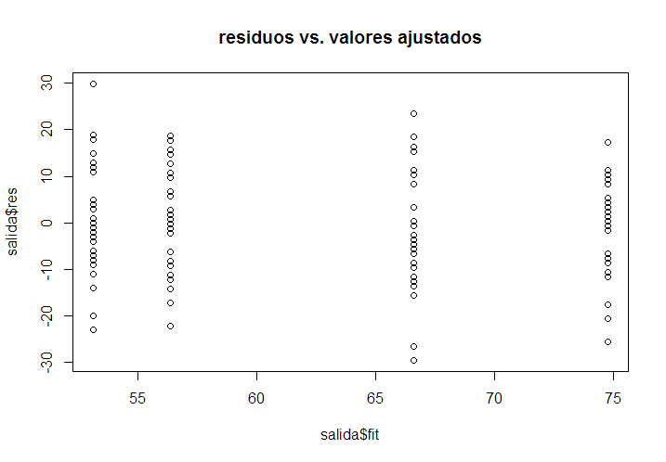

**> bartlett.test(tiempo,pais)**

Bartlett test of homogeneity of variances

data: tiempo and pais

Bartlett's K-squared = 2.5598, df = 3, p-value = 0.4646

**> library("lawstat")**

**> levene.test(tiempo,pais)**

modified robust Brown-Forsythe Levene-type test based on the absolute deviations from the median

data: tiempo

Test Statistic = 1.3867, p-value = 0.2504

**> boxplot(salida$res)**

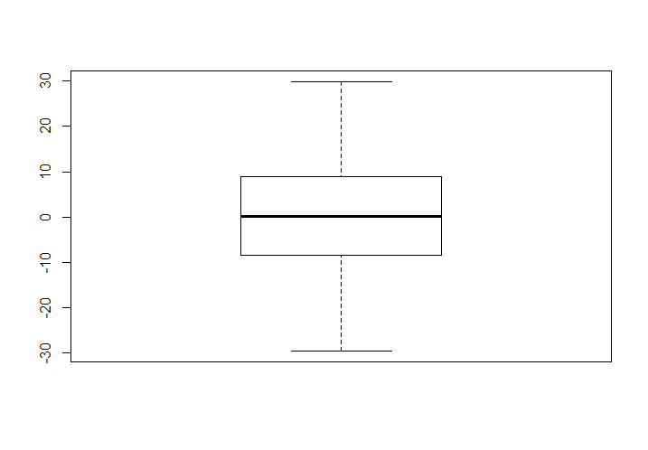

**>hist(salida$res,prob=T)**

**>x<-seq(min(salida$res),max(salida$res),0.5)**

**>lines(x,dnorm(x,mean(salida$res),sd(salida$res)))**

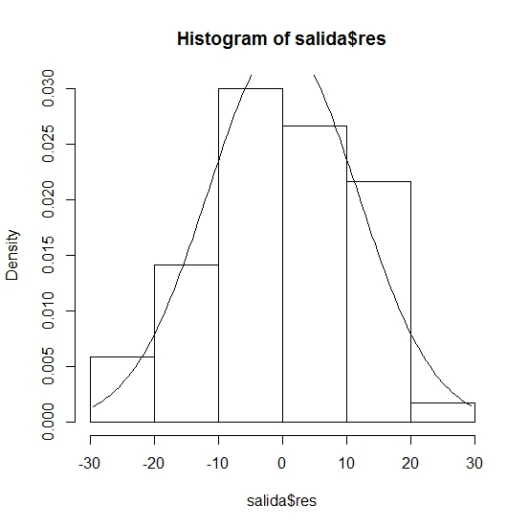

**> qqnorm(salida$res)**

**> qqline(salida$res,col=2)**

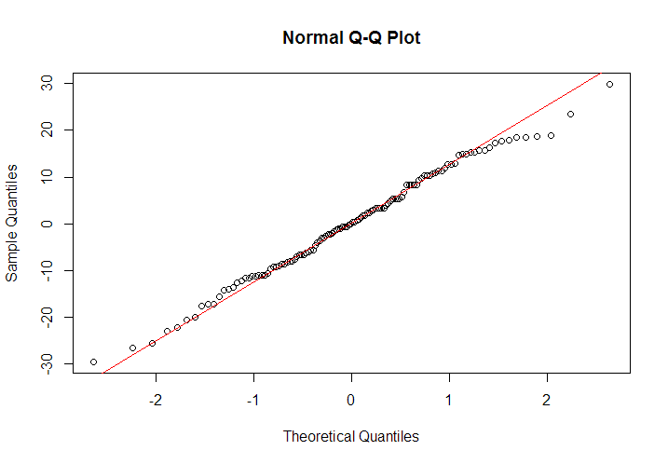

**> shapiro.test(salida$res)**

Shapiro-Wilk normality test

data: salida$res

W = 0.9921, p-value = 0.7312

**Cómo cargar un paquete en R?**

Ir a paquetes -> instalar paquete(s) ->seleccionar un cran mirror (por ejemplo el de La Plata)->OK->seleccionar el paquete (por ejemplo lawstat)